Experiment 6
An online food delivery platform enables customers to browse
restaurants, view menus, place food orders, make online payments, and
track delivery status. Restaurants use the system to manage their menus
and update order status, while delivery agents are responsible for
accepting delivery requests and updating delivery progress. Design a
Class Diagram, Use case Diagram and Activity Diagram for the Online
Food Delivery System showing the relevant classes, their attributes,
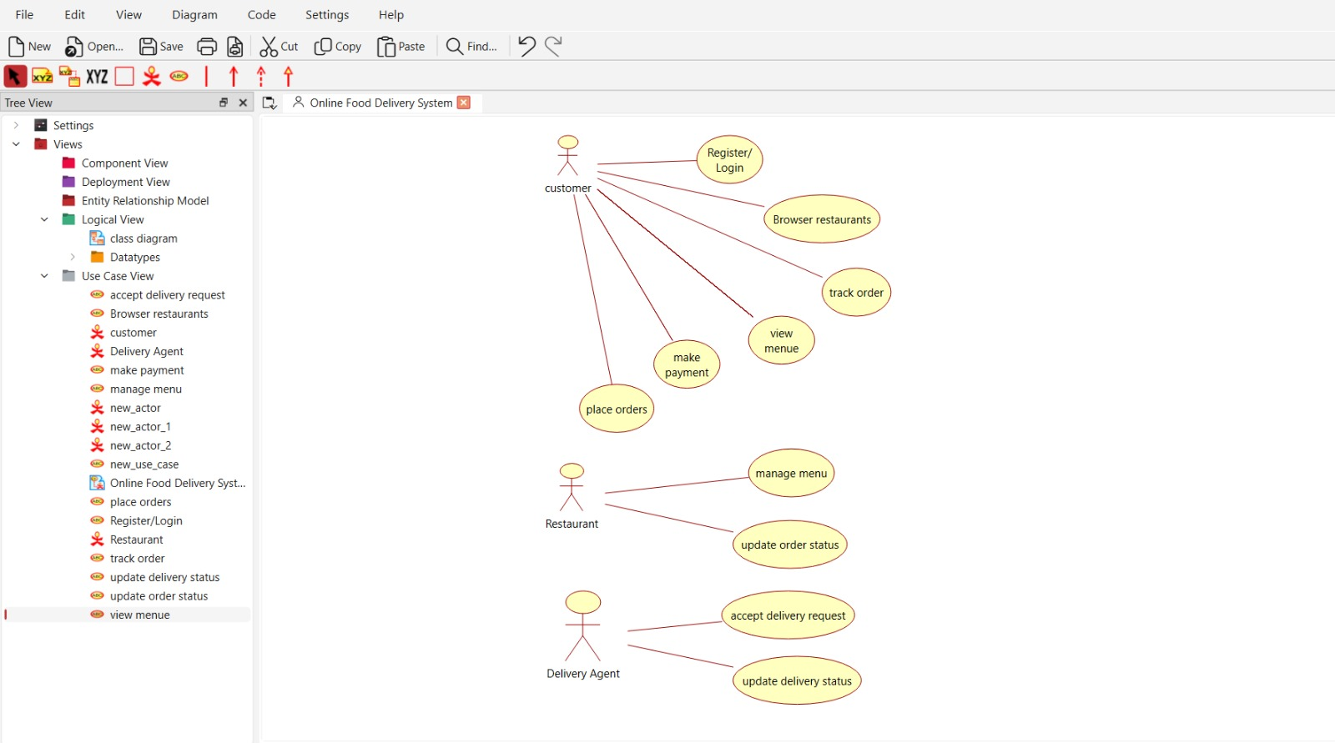
methods, and relationships.

